Unit 1 - Intro to Digital Photography Study Guide

CAMERA PARTS:
- An electronic device that has a main purpose of capturing and storing photographs electronically, instead of using photographic film is called a DIGITIAL CAMERA.

- A series of convex- and concave-shaped glass elements used to produce undistorted images on a film plane or CCD is called a LENS

- AUTO MODE is an automatic point and shoot mode where the majority of settings are controlled by the camera in result to shooting conditions.

- A mechanism that, when pushed down, causes the focal plane shutter to open and expose the film or CCD is called the SHUTTER RELEASE BUTTON

- The opening in the lens that determines the depth of field is called the APERTURE

- What stores the digital information, essentially saving your image, is called a SD CARD

- A device that produces an instantaneous flash of light in low light conditions to help illuminate a scene is called the BUILT IN FLASH

- The window on the back of a camera that allows the photographer to see external to be photographed is called the VIEWFINDER

TYPES OF LIGHT
- BACKLIGHT can cause a nice silhouette, but also mistakenly darkens faces too much in a posed portrait.

- DIFFUSED LIGHT lessens the contrast between lit and unlit areas of a scene, softening the edges of shadows and decreasing the strength of highlights throughout the image

- DAPPELED LIGHT is type of light occurs when light is blocked in some areas and able to shine through in other areas of the scene, projecting light and shadows onto your subject as a result.

- DIRECT LIGHT shines straight onto the subject.

- GOLDEN HOUR refers to the hour right after sunrise or right before sunset when the light is at its richest.

OTHER ELEMENTS OF PHOTOGRAPHY:
- FORM is the 3-D version of a shape or subject, created by highlights and shadows.

- The distance from the foreground to the background that is in acceptable focus is called DEPTH OF FIELD

- BOKEH is derived from a Japanese word used to describe “the pleasing or aesthetic quality of out-of-focus blur in a photograph”.

- The clear and sharply defined condition of an image; the position of a viewed object or the adjustment of an optical device necessary to produce a clear image is called the FOCUS

- A PIXEL is short for “picture element”, referring to the basic unit of programmable color on a computer display or digital image.

- COLOR CONTAMINATION occurs when a colored object within the scene reflects its color onto other items or people.

EXPLAINING SHUTTER SPEED
The shutter on your camera are like barn doors, opening and closing, and you control the speed at which those doors let in light and shut it out. The shutter moves incredibly fast, like a blink of an eye. Not only does Shutter Speed capture LIGHT in a photograph, but it also controls MOTION. So if you want to FREEZE your subject mid-air, then you want a fast shutter speed. Think 1/500th of a second or more. If you want to BLUR motion, slow your shutter speed down to 1/10th of a second or slower.
EXPLAINING APERTURE
The aperture of your camera is the opening and closing of the lens. The opening is a hole that can let in a lot of light or be closed to block out the light. Think of the aperture as you would the pupil of an eye. When it dilates, aka the hole gets BIGGER, the lens lets in more light. When it contracts, aka the hole gets SMALLER, the lens closes off the light.
When the hole in the lens is BIGGER, it:
- Lets in more light
- Makes the background of the scene get fuzzier

When the hole in the lens is SMALLER, it:
- Blocks out some light
- Makes the background of the scene go in focus
The aperture is measured by units of FSTOPS in your camera. The smaller the fstop number the BIGGER the hole becomes and lets in more light. The bigger the fstop number the SMALLER the hole becomes and starts to block out light. Yes, that does seem backwards. But the graphic below will help! Think about the F number measuring the thickness of the black ring instead of how big the hole is getting.
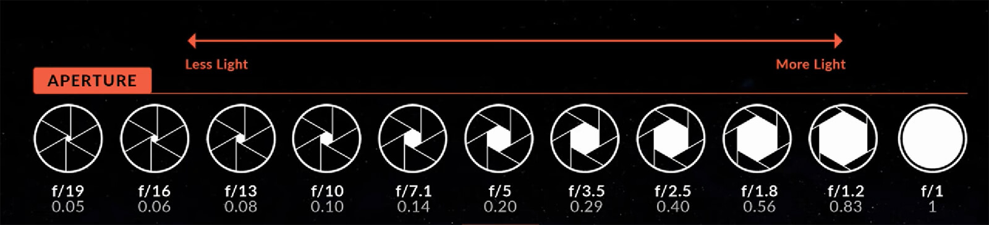

EXPLAINING ISO
ISO refers to the sensitivity of the image sensor in your digital camera. The lower the number is, the LESS sensitive it is, this works great in the daylight or outdoors. The higher the number is, the MORE sensitive it is, and that works great in dark rooms or outdoors with no sunlight (aka early morning and evening times).

PUTTING IT ALL TOGETHER: THE EXPOSURE TRIANGLE:
When you operate your camera in full manual mode, you will be adjusting the SHUTTER SPEED, APERTURE (FSTOP), AND ISO all at once to get a correctly exposed image. Pay attention to the number graph in the window of your viewfinder to help guide you to the correct exposure. The closer the tick marks are to the ‘0’ the closer the image will look like you hope it will. See the graphic:
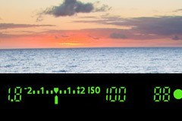

Before taking a photo, you must ask yourself a few questions:
- Is my subject MOVING and do I want to freeze them or blur them? That determines your shutter speed.
- Do I want the whole scene in focus or just my subject? That determines your aperture/fstop.
- How bright is it where I’m standing? That determines your ISO.
